**Week 2(1) - ServiceNow Admin Full Course**

Servicenow platform- the servicenow platform is an application platform as a service, it is a cloud based computing model which provides the infrastructure needed to develop, run and manage applications

Servicenow platform can be used in different IT Business Management sectors and can be inculcated in any service managements.

Servicenow architecture:

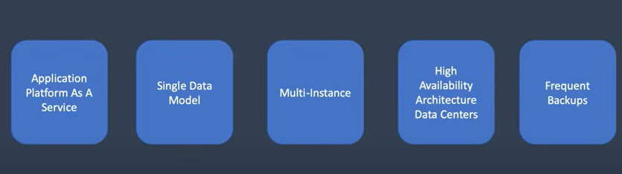

Multitenant instance provided because the data from one company doesn’t gets involved with the other as there will be a separate instance which will be provided to each company.

Backup is provided as 6 days of daily differential backup and 4 weekly full backup from the main instance to backup instance and vice-versa.

Security is provided by giving the availability for single sign-on, two step verification and by role based access.

Ways of interacting with Servicenow

* User interface
* Mobile interface
* Portal interface

All these interfaces can use the same instance with the same data source.

Mobile Apps:

* Servicenow Agent – used by the agents to give an accurate answers for the customers
* Now mobile ­­­– used by the employees and the customers to request any services.
* Servicenow onboarding – this app helps in recruiting the people for the servicenow.

Service portal is a web-based interface that provides a more user-friendly and customizable way for users to interact with ServiceNow's functionalities. Each different user, based on their assigned role has a different service portal access for the data.

Supported Authentication

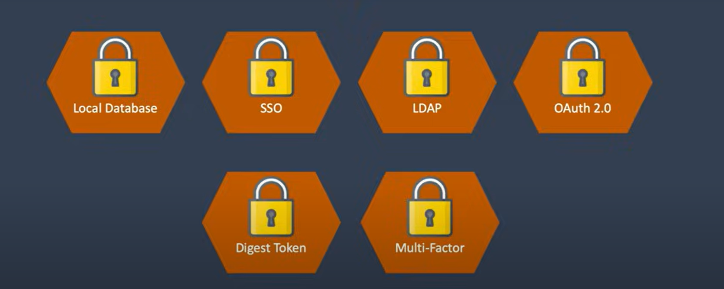

Role based access-

Each individual is given different kinds of access based on their roles and for example few roles are: itil, admin, knowledge admin, approver, system administrator.

Components are:

* User – the individual that uses the services
* Group – the users gets added into the groups based on their roles and one group can have many users and 1 user can be any number of groups.
* Role – collection of permissions in the Now Platform.

Groups: Roles:

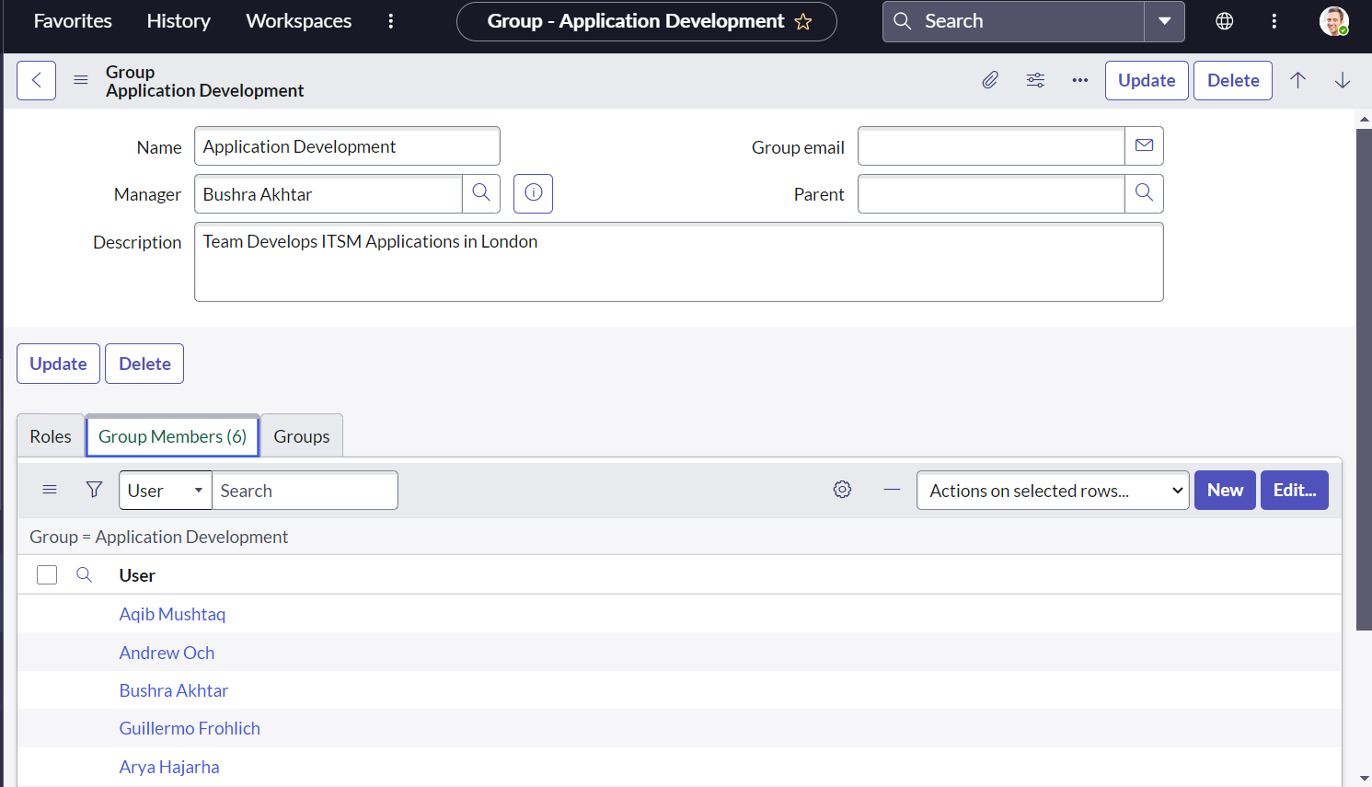 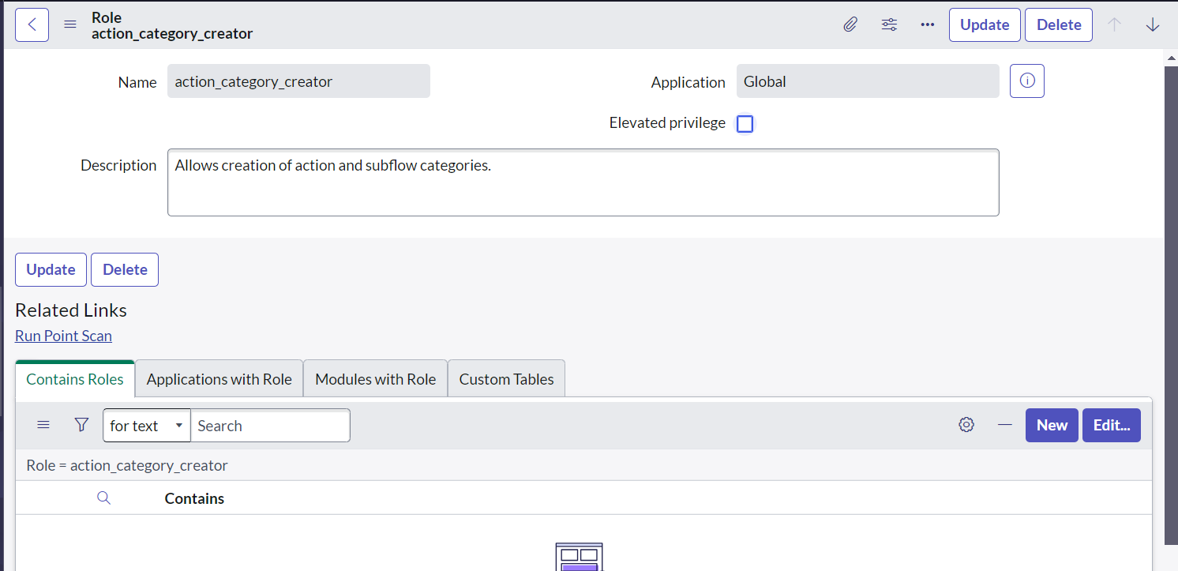

Roles assigned to a Group:

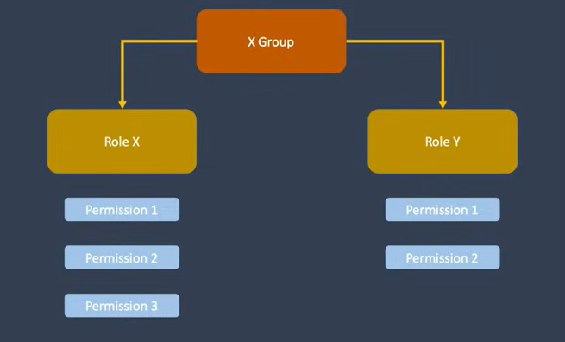

I can create user as I logged as a system administrator. For that we need to navigate to the users table in the system security.

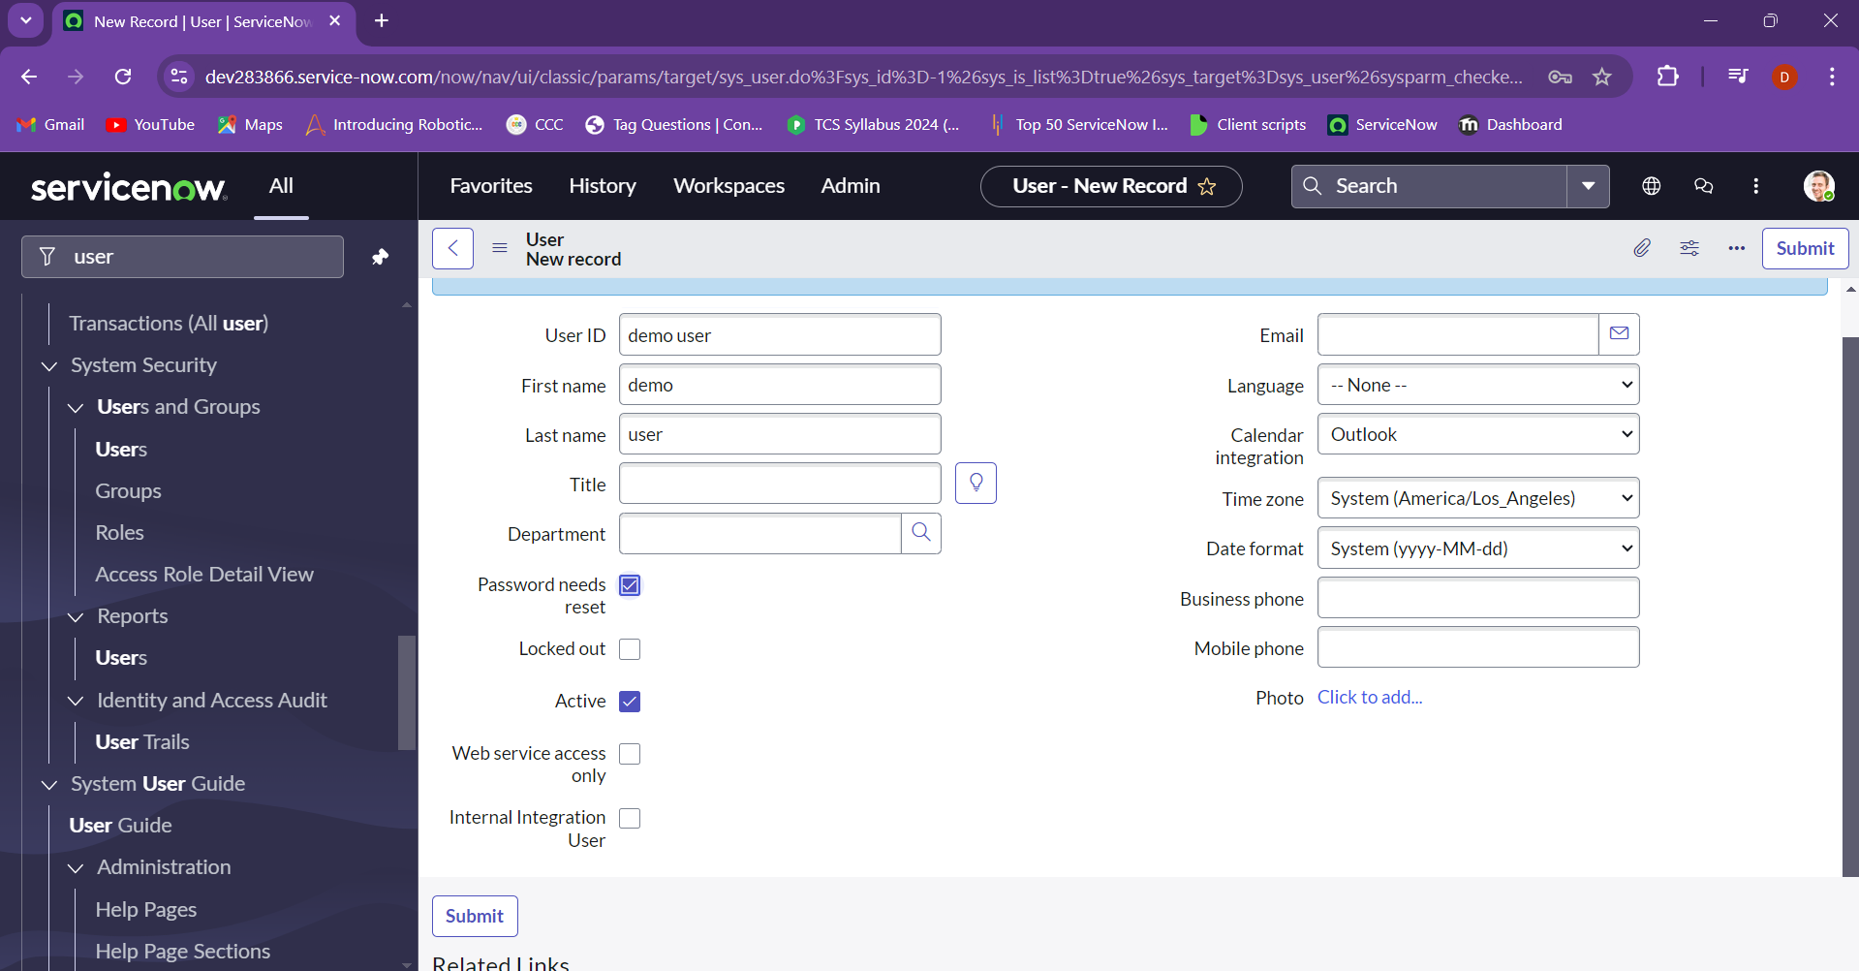

Now we impersonate into demo user and then to the itil user.

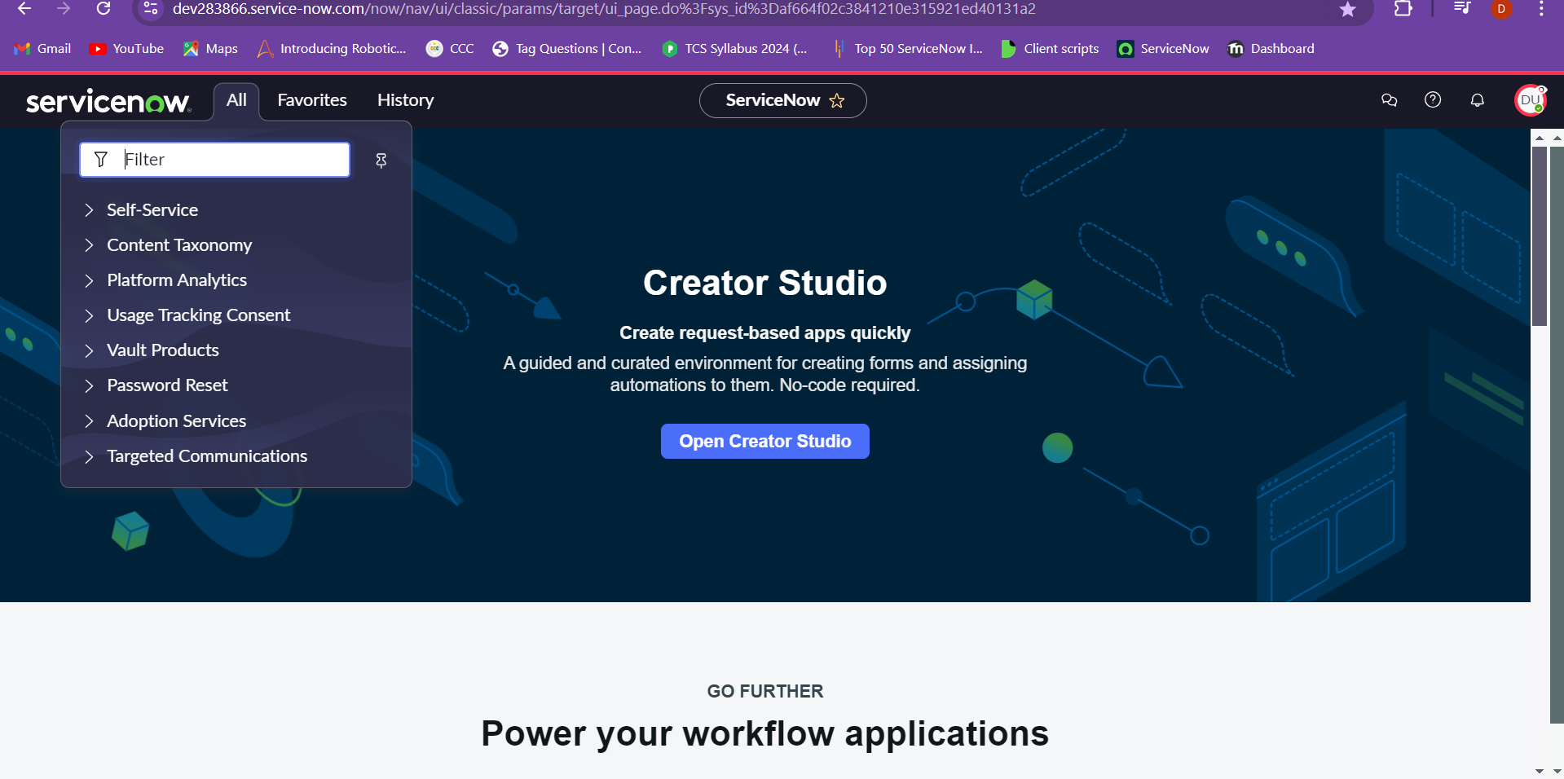

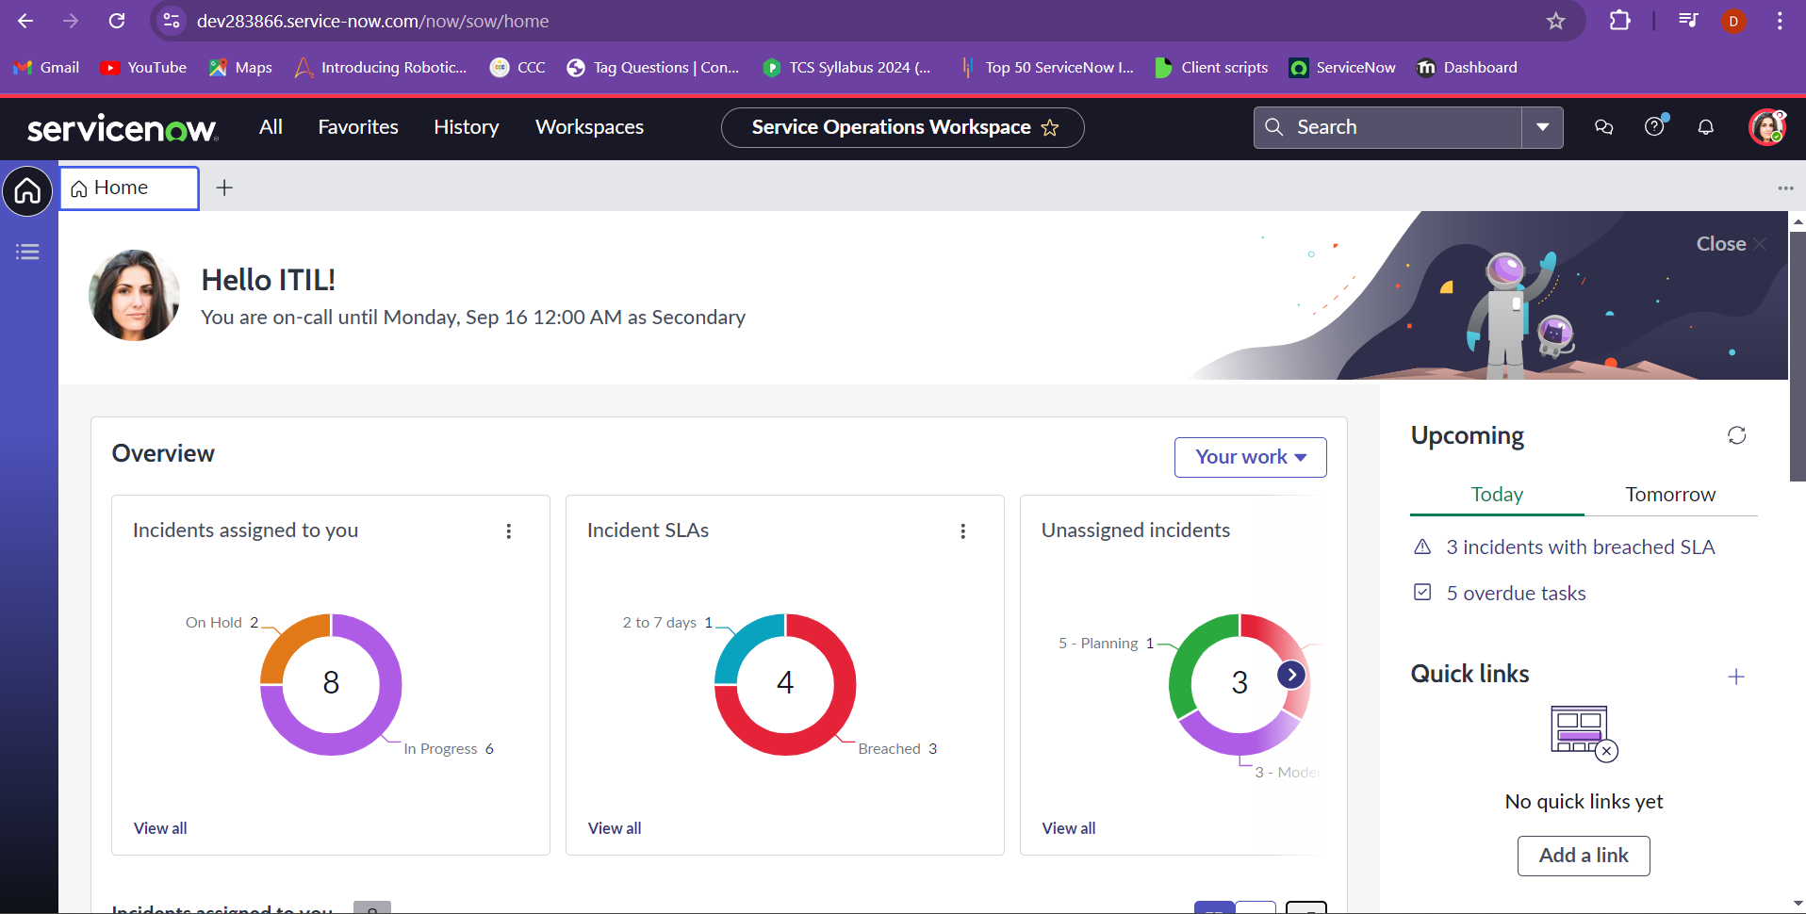

Now in the working region there are three main parts – Banner frame is the header of the portal which contains profile, scope and etc.

Application navigator is where we can find the different types of services that are required for the user and they are user specific.

Working frame is where we can be working on. In my understanding it can be used as a canvas for your work.

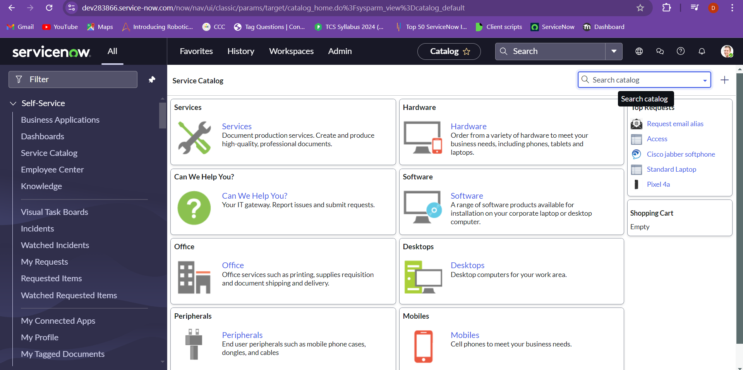

Creating an instance:

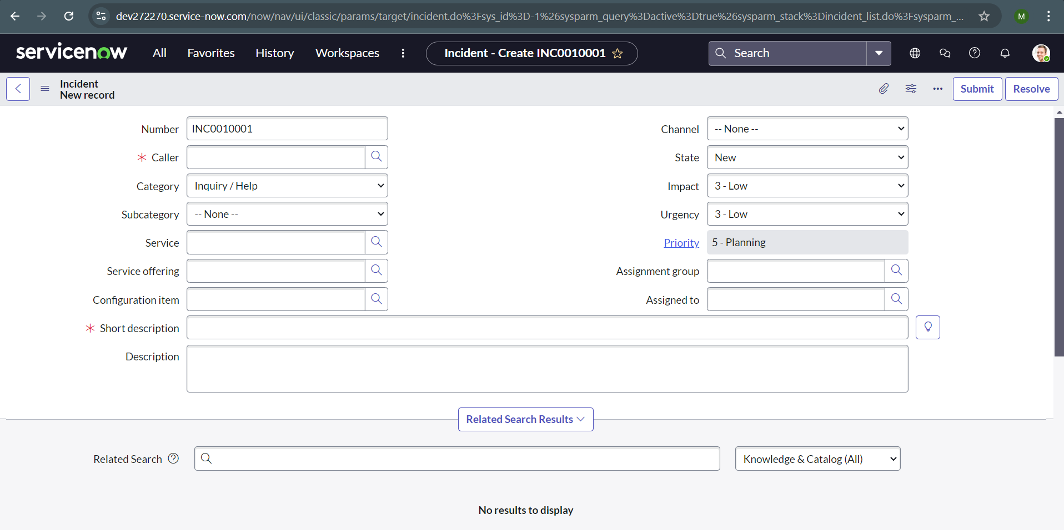

Branding in servicenow:

Branding: Customizing the ServiceNow platform's appearance to reflect your organization's identity. This helps build trust and encourages users to adopt the system more quickly.

Guided Setups:

* ITSM Guided Setup: Helps you configure IT Service Management features.
* ITOM Guided Setup: Assists with setting up IT Operations Management tools.

Service Portal: A tool that uses widgets to create user-friendly interfaces, making it easier for users to interact with the ServiceNow platform.

UI Builder: A tool that lets you design and build custom, functional pages within the platform to meet your specific needs.

To complete the changing of the banner we need to open the instance.

Here I’m using servicenow.developer instance

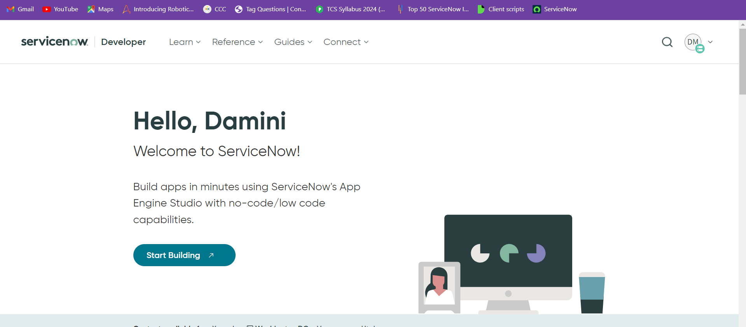

Which would then take me to the instance

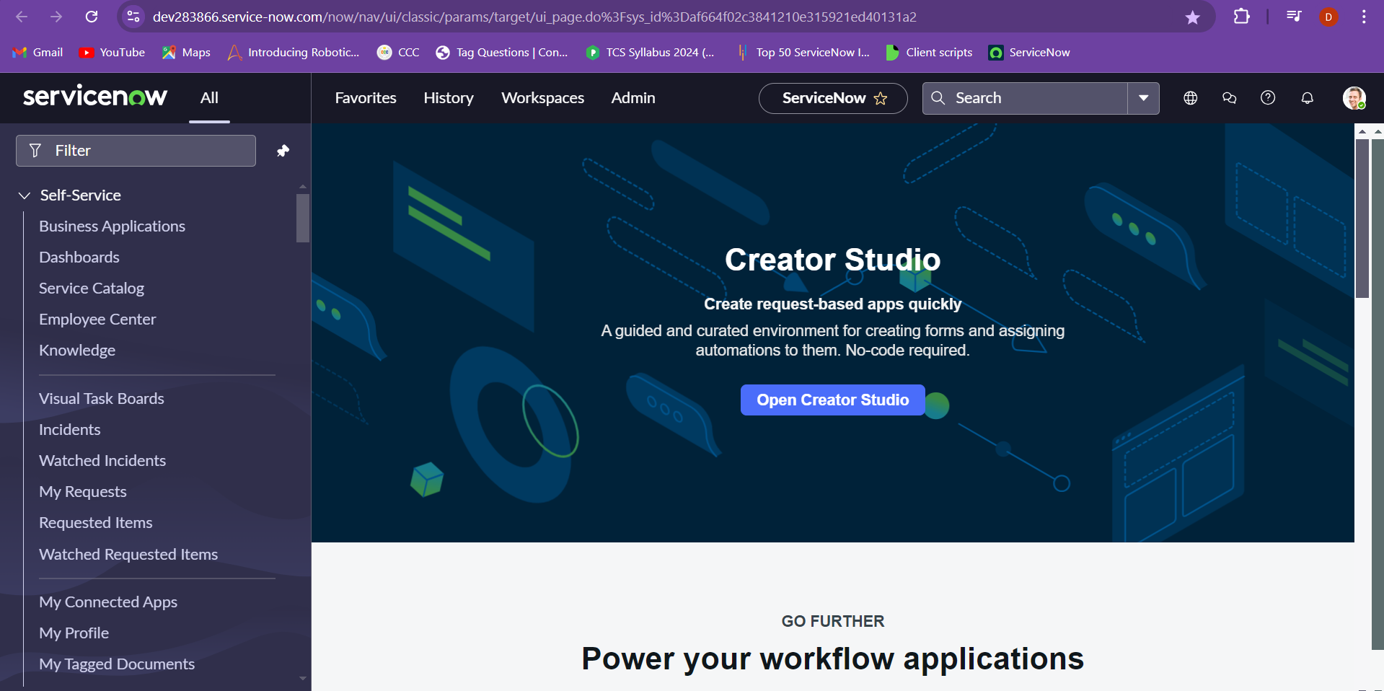

Go to guided setup and choose ITSM guided setup

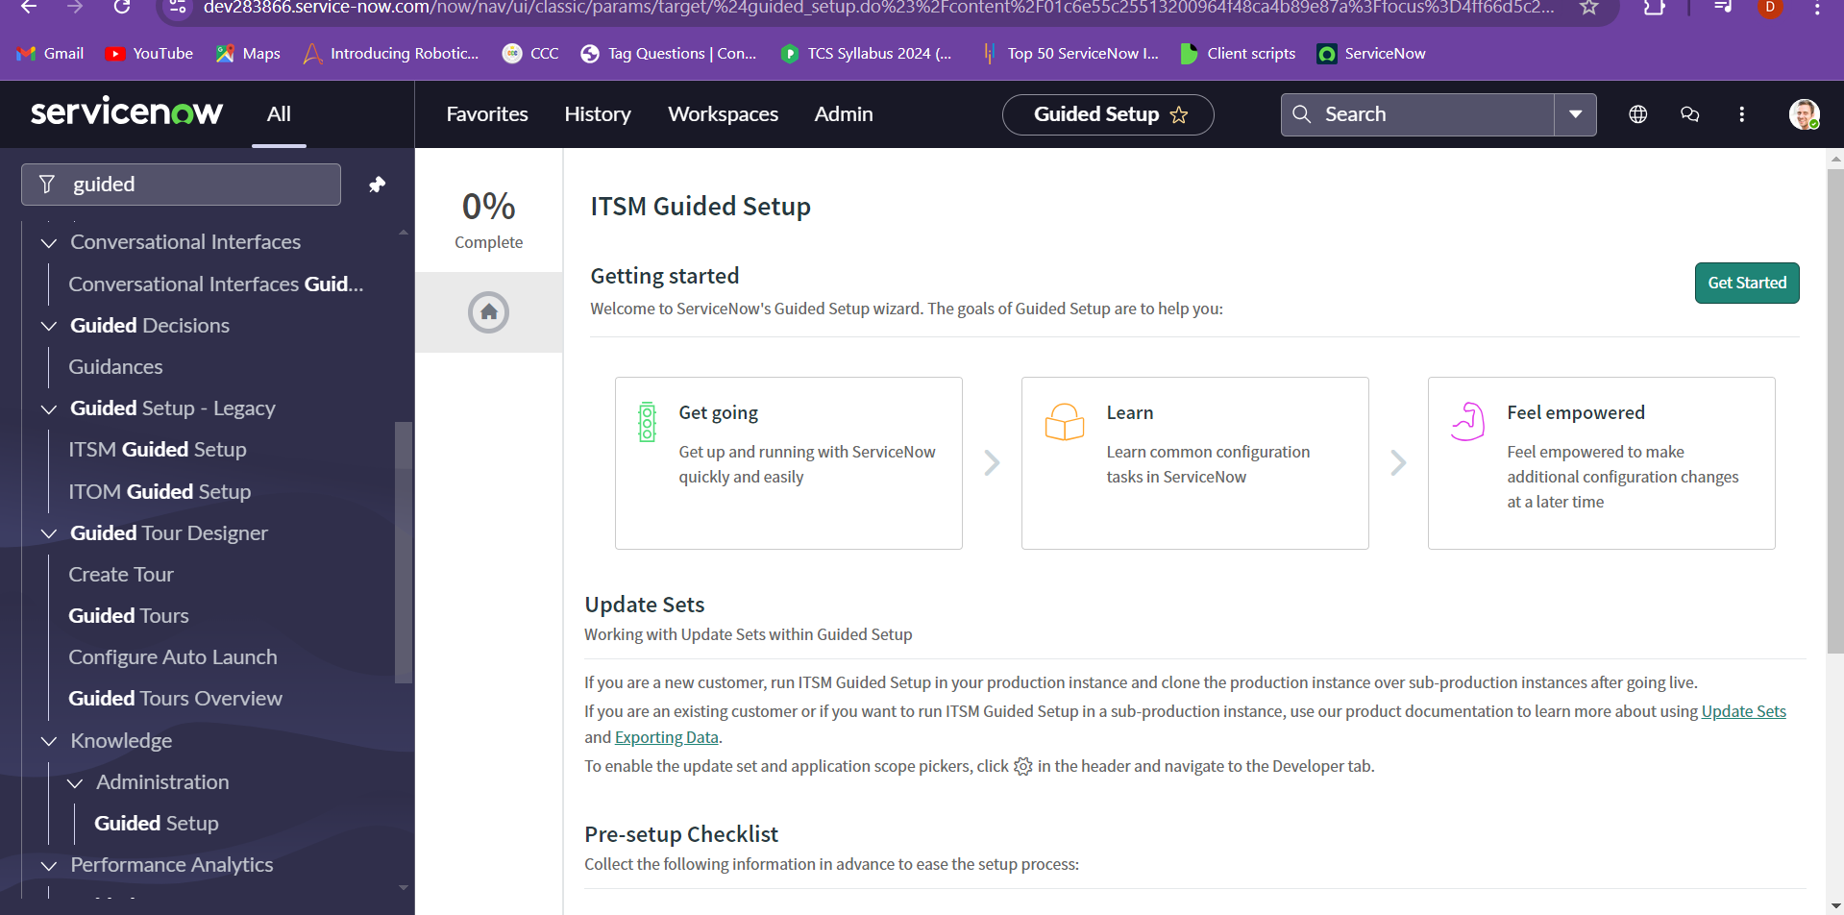

Click on get started. And choose the company, under system configuration choose the get configure.

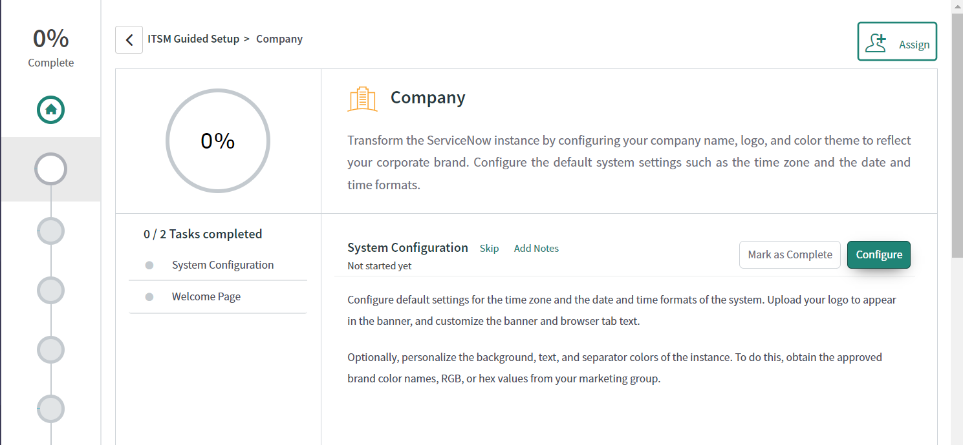

Now we can add the banner image and the banner names as needed for the requirement.

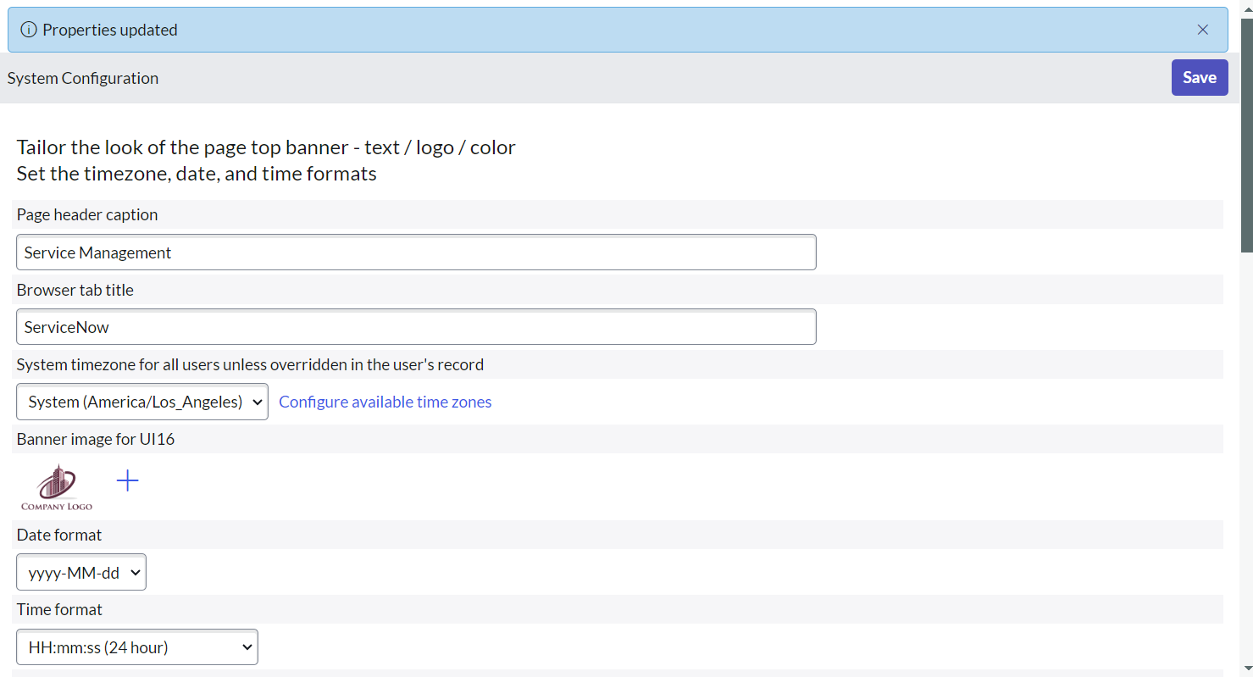

Now we can see the updated logo image.

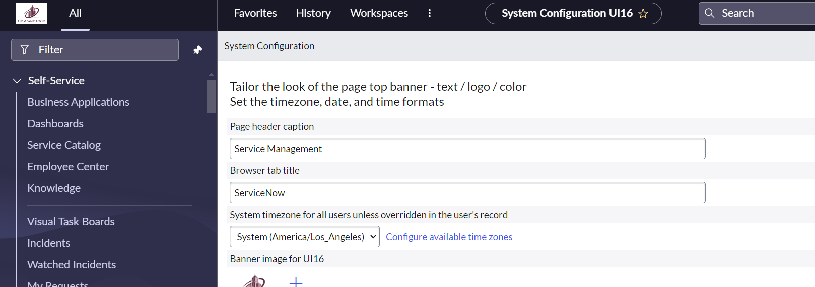

Lists and Forms:

Lists: Display records from a table in a tabular format, allowing you to view, sort, and manage data.

Filters: Enable you to refine and narrow down records by applying specific conditions to display only the relevant data.

Choose the incident and then sub division all is choosen:

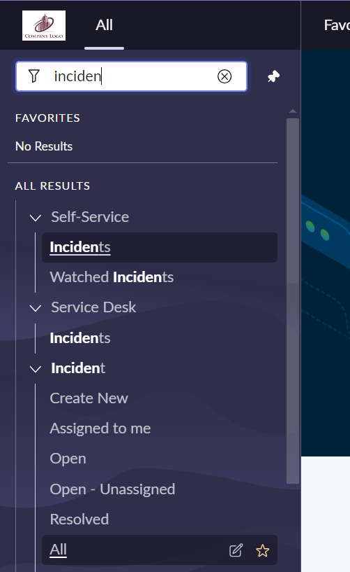

You will be then transferred to the incident list and the whole list is visible or you can choose the incident.list in the navigation bar.

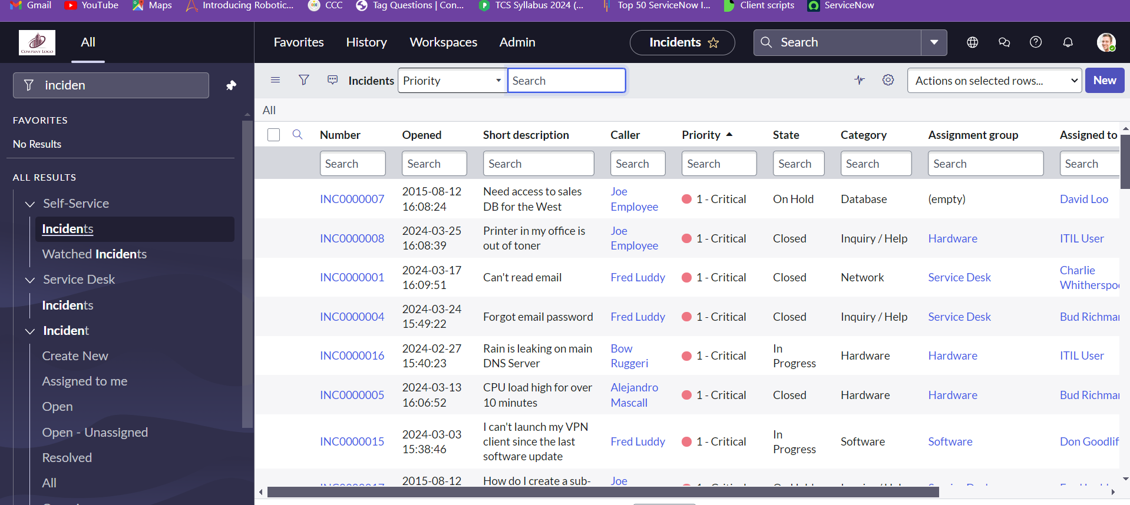

We can create new incident which is a form that gets opened to create a new incident.

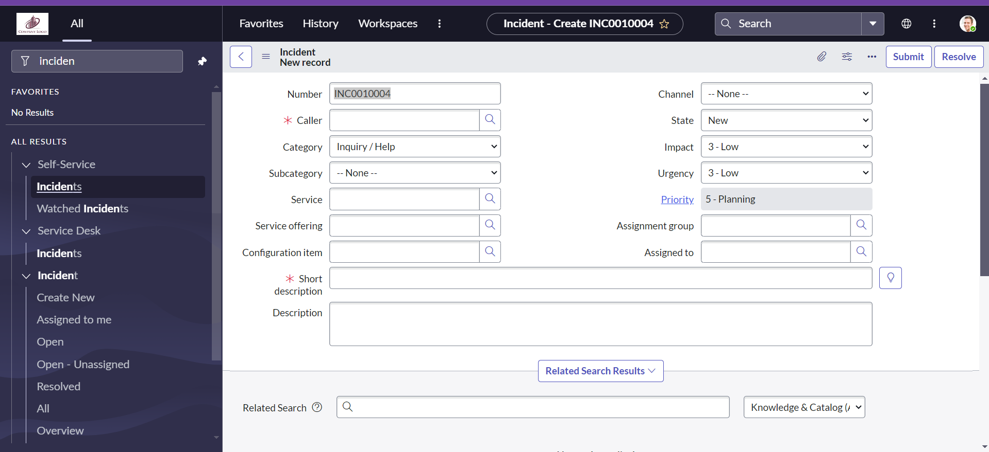

Accessing Table Views:

To see a list of records in any table, type the table name followed by .list in the URL. For example, Task.list will show a list of tasks, and Sys_db_object.list will show a list of database tables.

Creating New Records:

To create a new record in a table, use .form after the table name. For instance, Task.form will open a form to add a new task.

Personalizing Lists:

Use the gear icon to customize which columns are visible in your list view. This personalization only affects your view, not other users’. You can move columns in and out of view and rearrange their order using the arrow keys.

Filtering Data:

The filter icon allows you to add and combine multiple conditions to refine your data. You can also sort and choose which columns to display as part of your filter criteria.

Visualizing Data:

You can view data in graphical formats like bar charts or pie charts. This helps in analyzing and interpreting data trends more easily.

We can see the lists and customize the data that is found and we can take an example of incidents list. And will be able to use the filter on the incident table according to the requirements.

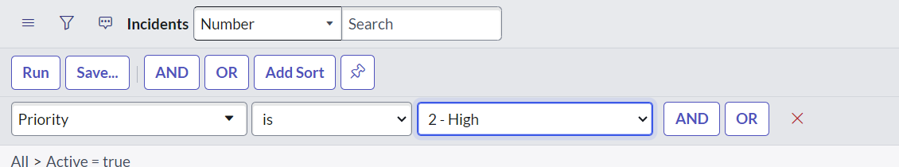

Creating an incident as a favourite.

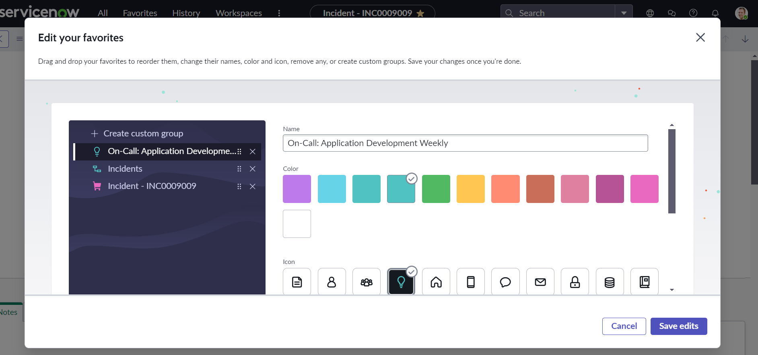

Creating a bar chart for the given incident table field by clicking on the field tab and selecting bar chart, we can also change it to pie chart and bar chart accordingly.

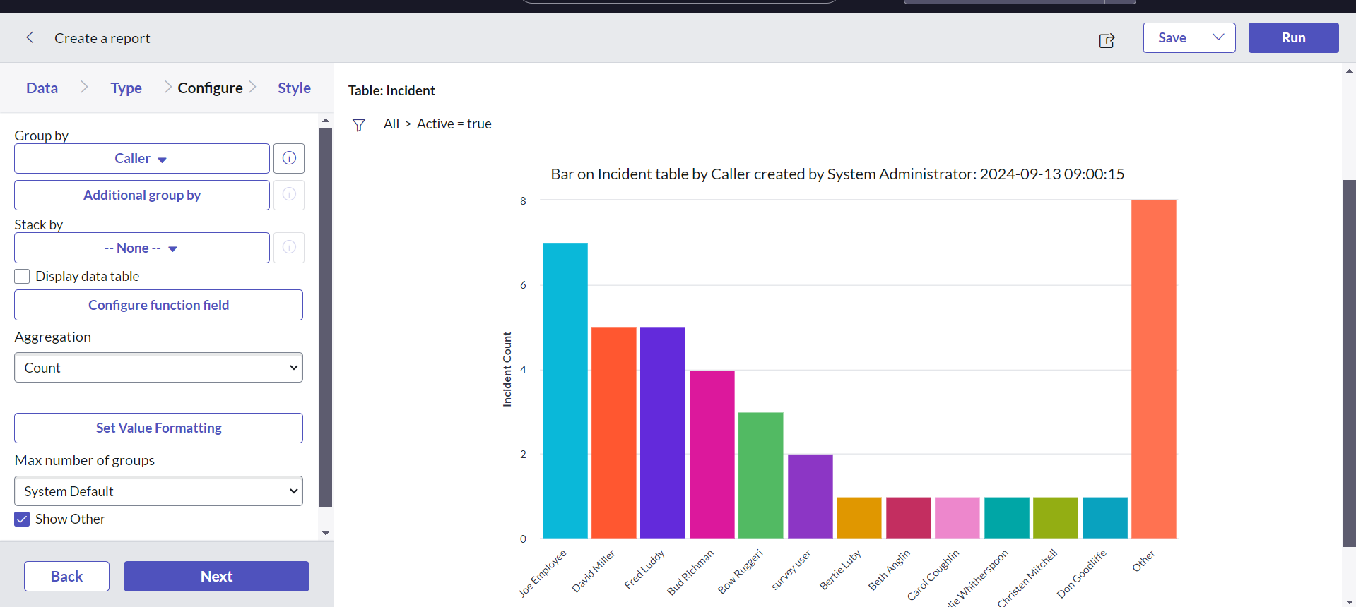

We can also use the personalize list to add or delete any column fields to the table.

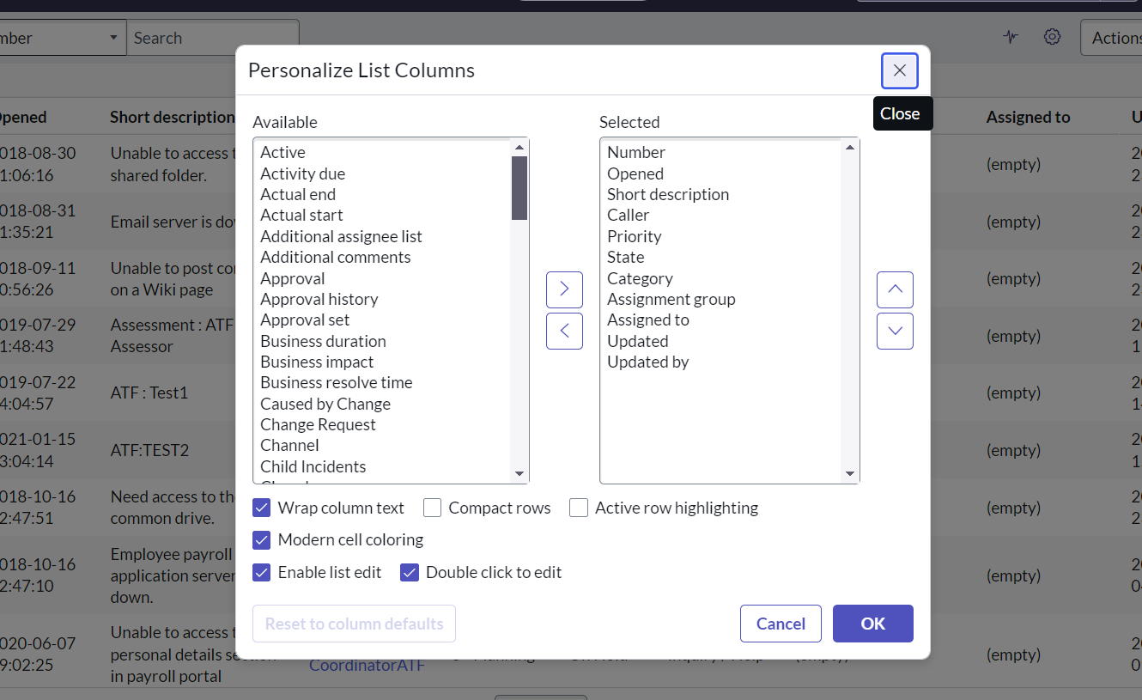

When we navigate to the configure and then to the list control we can find the list control form which can be used to add or change the role that has been added to the incidents and etc. along with it there are many other features like import and export into various types of data.

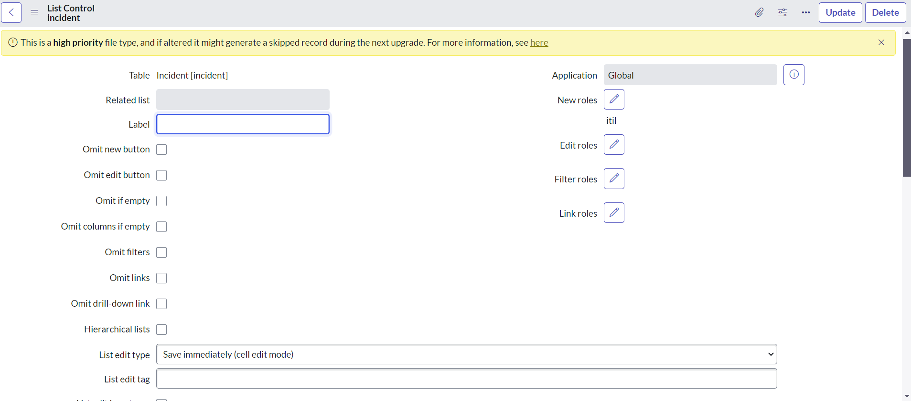

Updating the selected incidents from the options of the field.

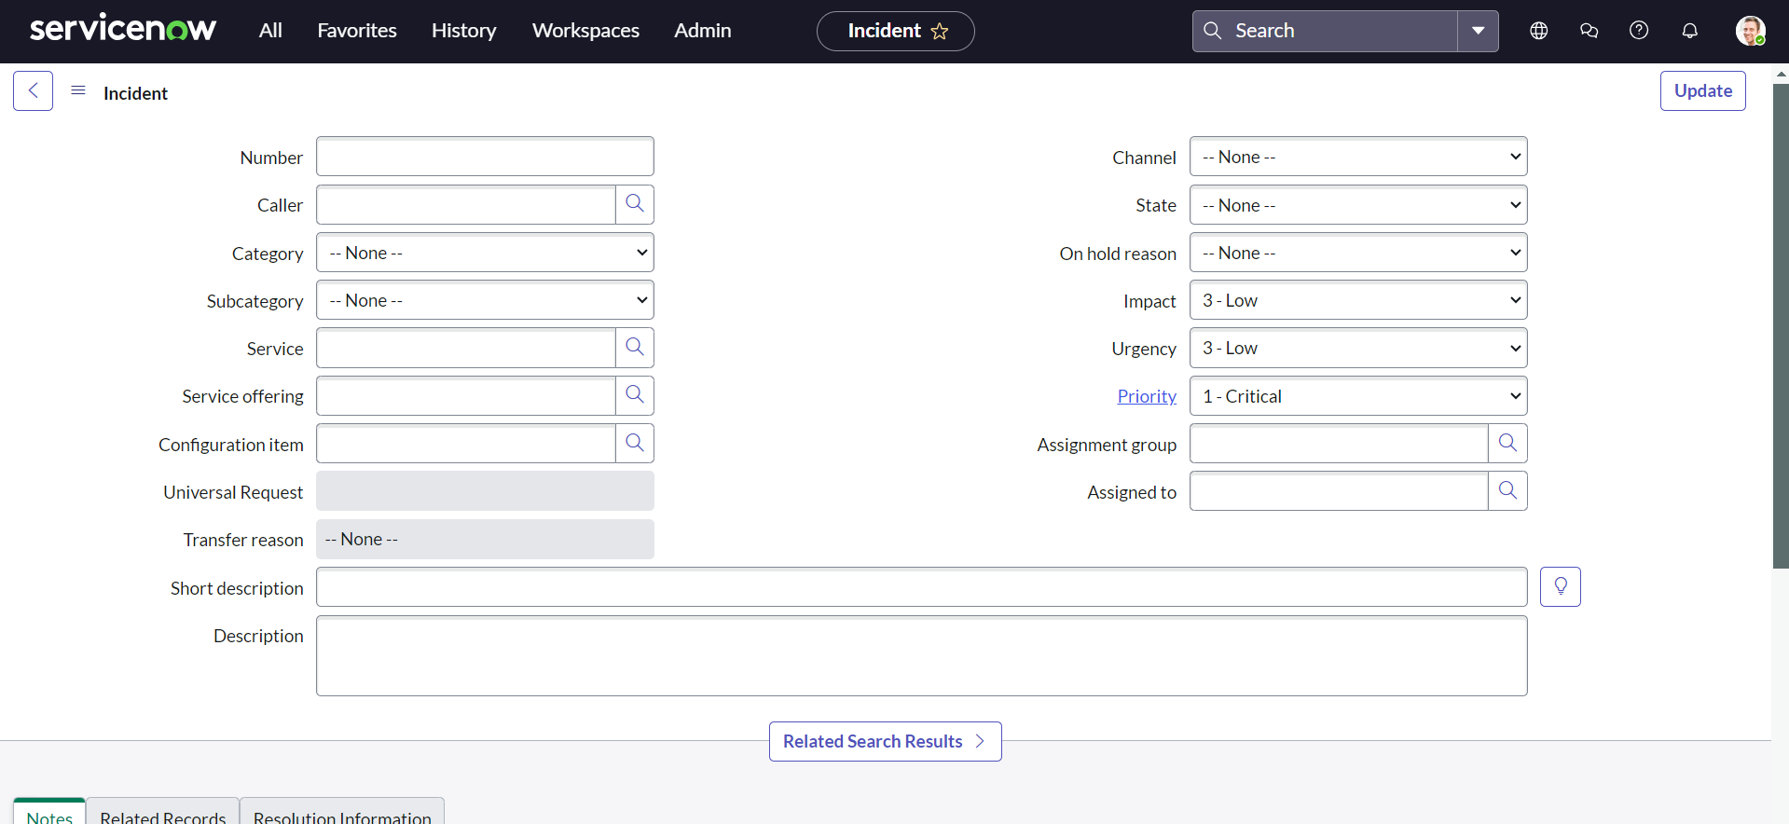

Form elements are those which allows the information for a record to get stored.

Content form is where the details of the record are displayed, Form buttons are also known as UI actions, form menu to perform some functionalities.

For example we can create a new form (new incident) and the fields that has star is the mandatory fields that are to be filled and the read only fields like priority will allow the user to read.

Once we save the changes we can see more number of options displayed and notes available for other people to look at when update the assigned to and the assigned group or any other notes.

We can change the view depending on our choice. 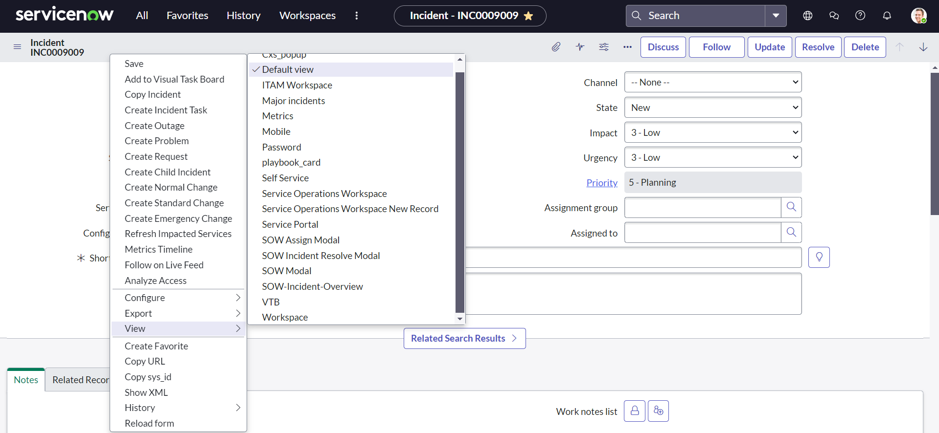

Form layout:

We can add the fields or remove the fields, and also create a new field for the incident record based on the form view and section.

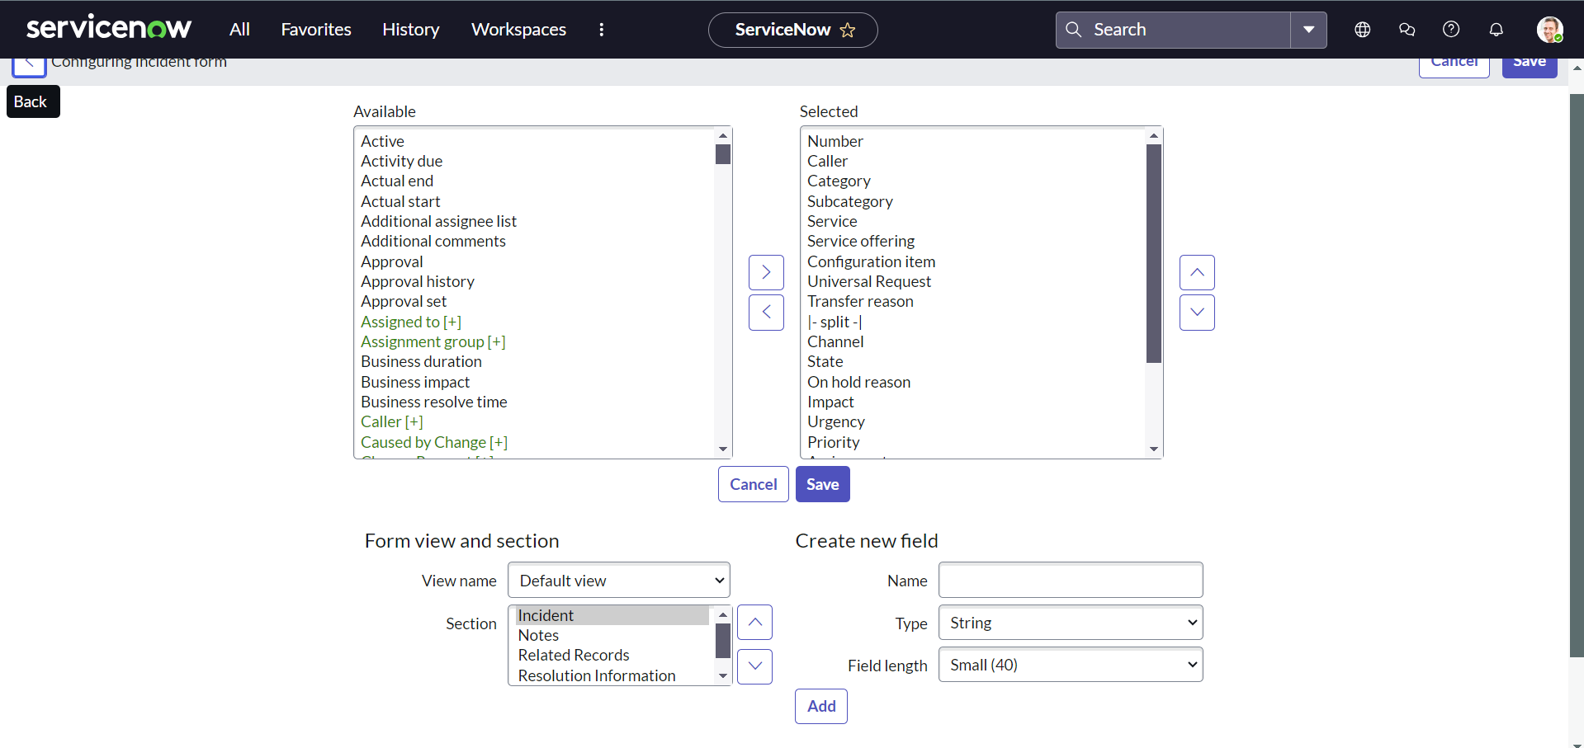

Form design:

We can change the placements of the field items by using form design and also add new items with their properties and acess being specified. This uses the drag and drop system to add or change the fields

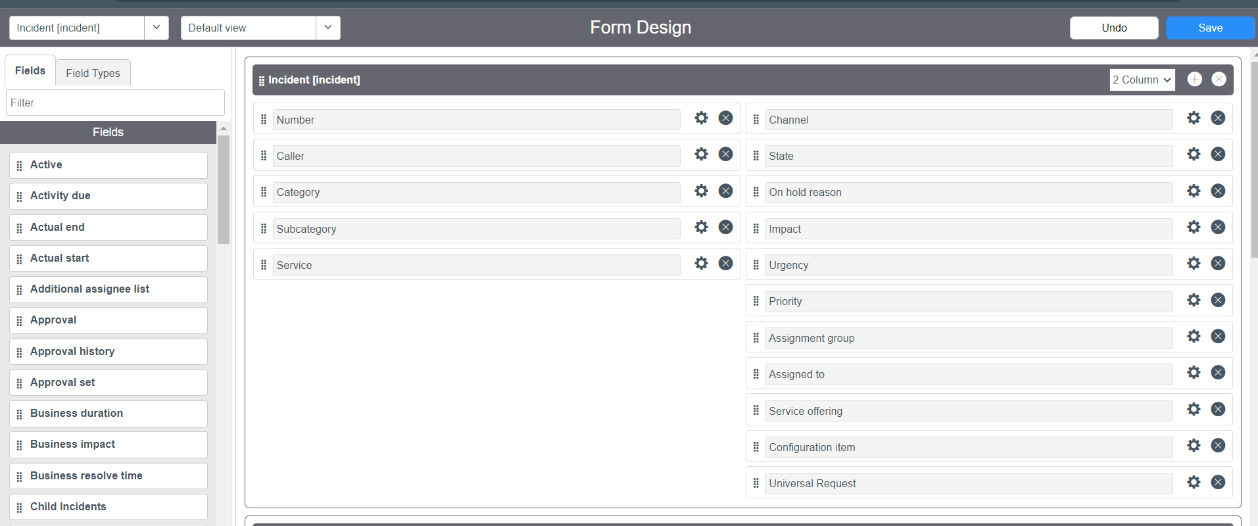

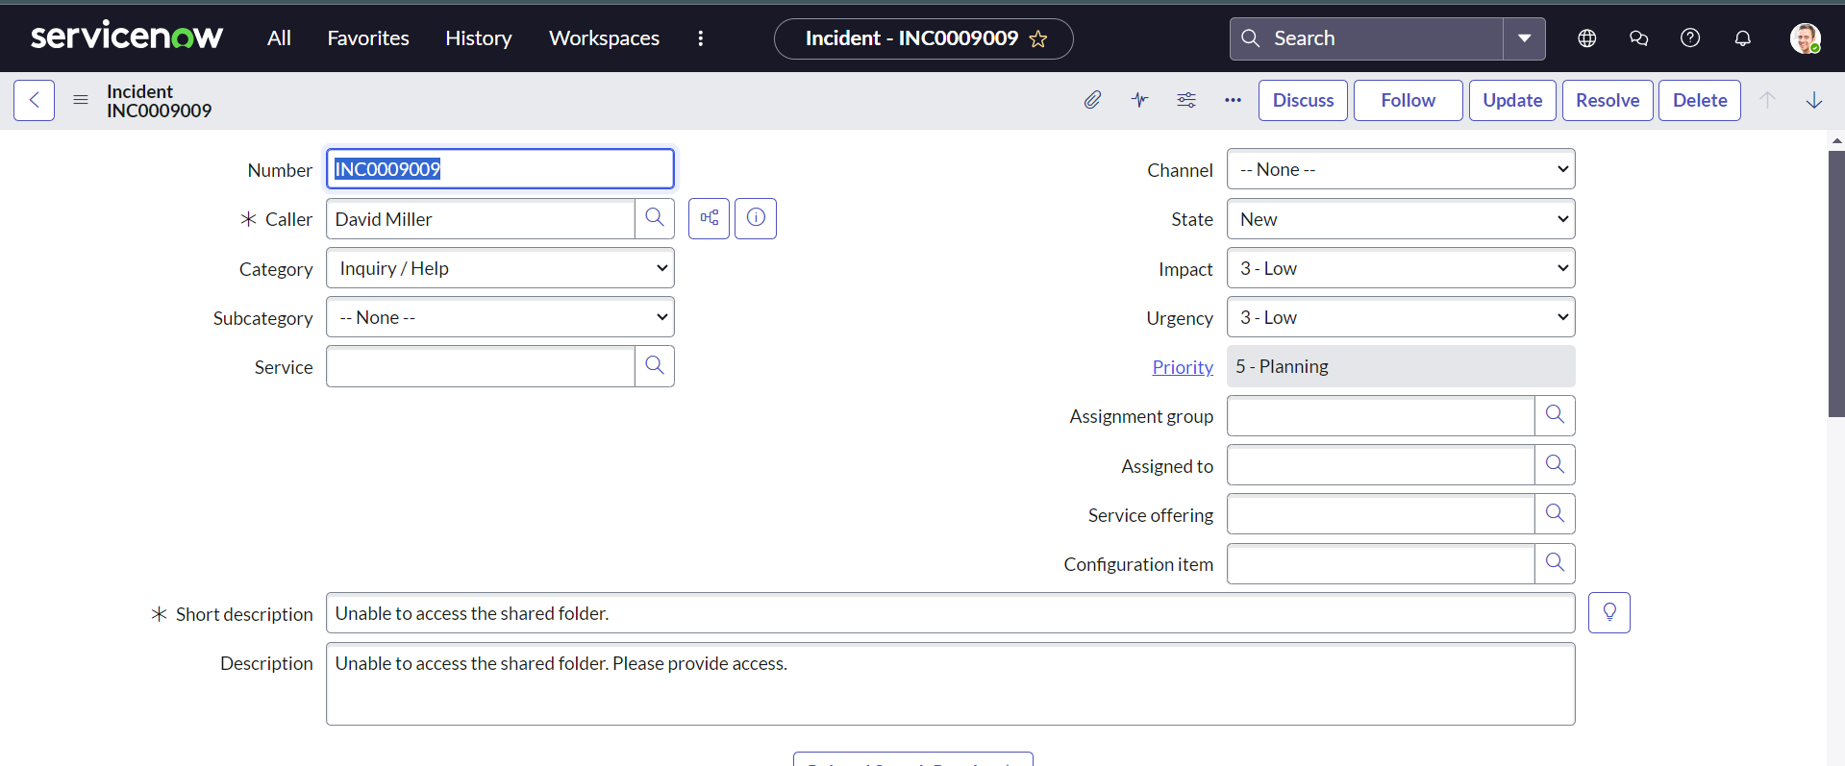

Template creation: the template creation can be used when we need to add a specific kind of records on daily basis and need to create own fields for the form we use template creation.

Task Management:

Task:

A task is any record that can be assigned or completed by a user in ServiceNow. Users create tasks and are notified as the task moves along a workflow. Tasks can be assigned to specific users or user groups.

Task Workflow:

The work order when an incident or a particular process needs to be performed to complete task is called as task workflow.

Task Table:

* Incident table
* Request table
* Change table

Functionalities associated with task:

* Approvals
* Assignments
* SLA

Task can be assigned to a particular user or a group and they would be attending the assigned task related to their job role.

Many tables get extended from the task table like incident table, assigned to, assigned group, change request etc. All these tables will be having some fields in common and few specific fields made for their own tables.

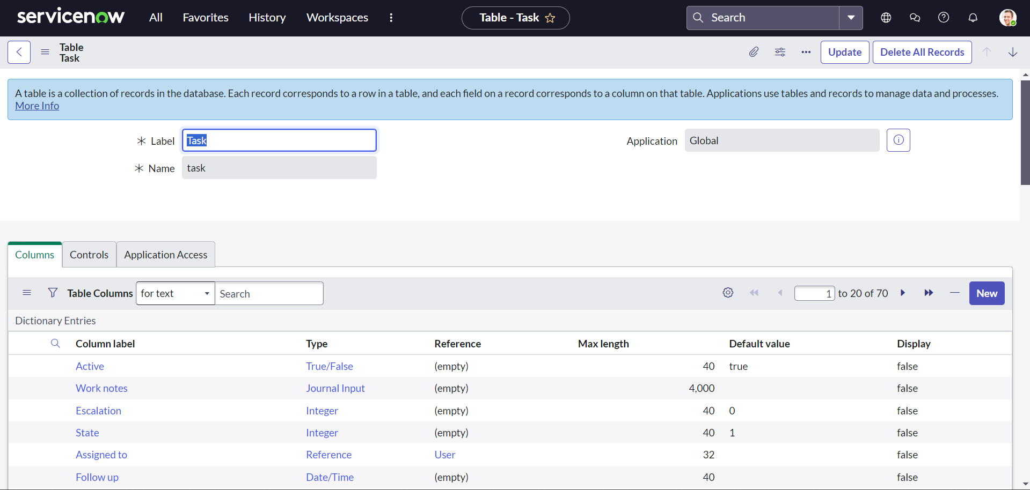

The above is the task table in the tables

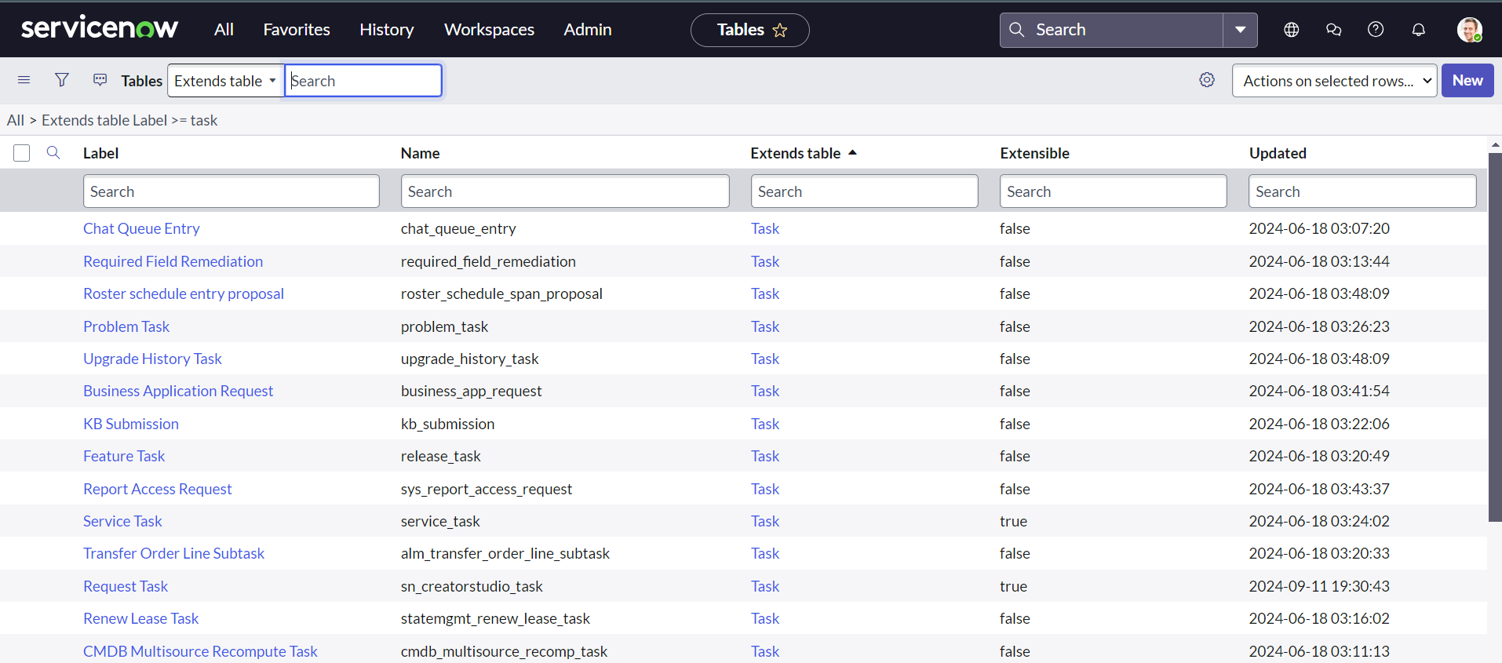

Fields of incident table that are created from different references.

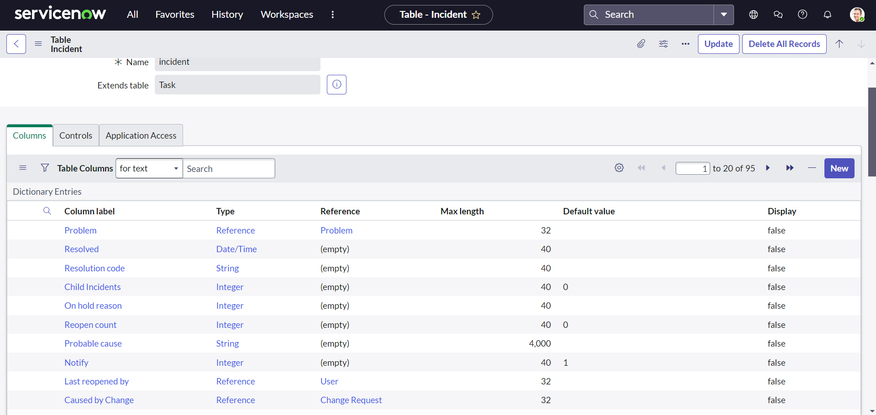

Now by clicking on the show lists in the bottom I can see the total list of the record tables that are created under all tables.

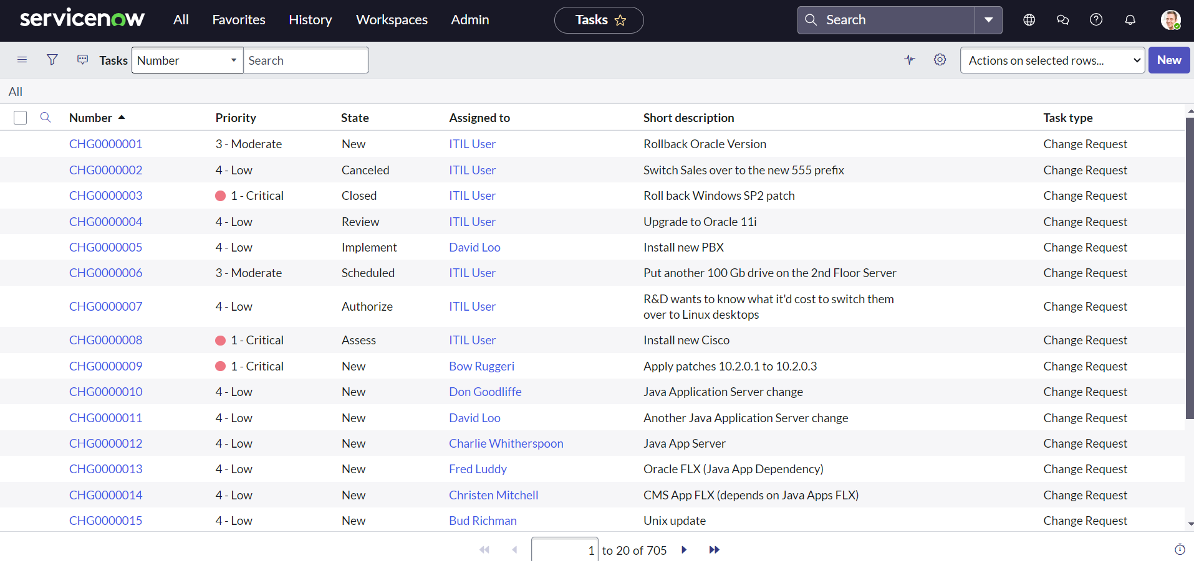

If we go into any particular record in the incident table and go to the bottom we can find the SLA that are related. 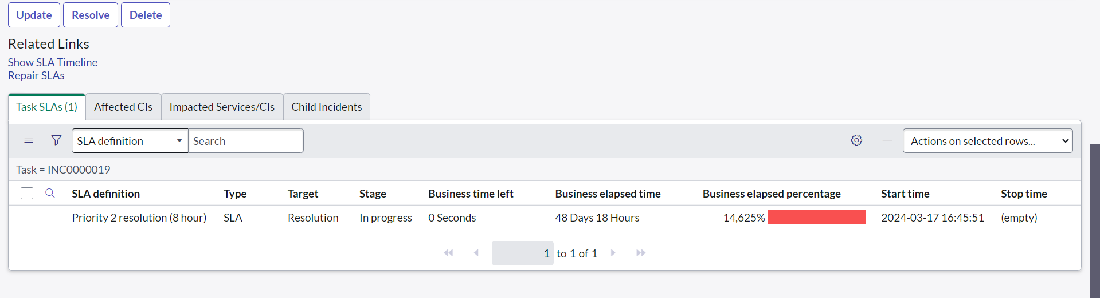

SLA Definitions

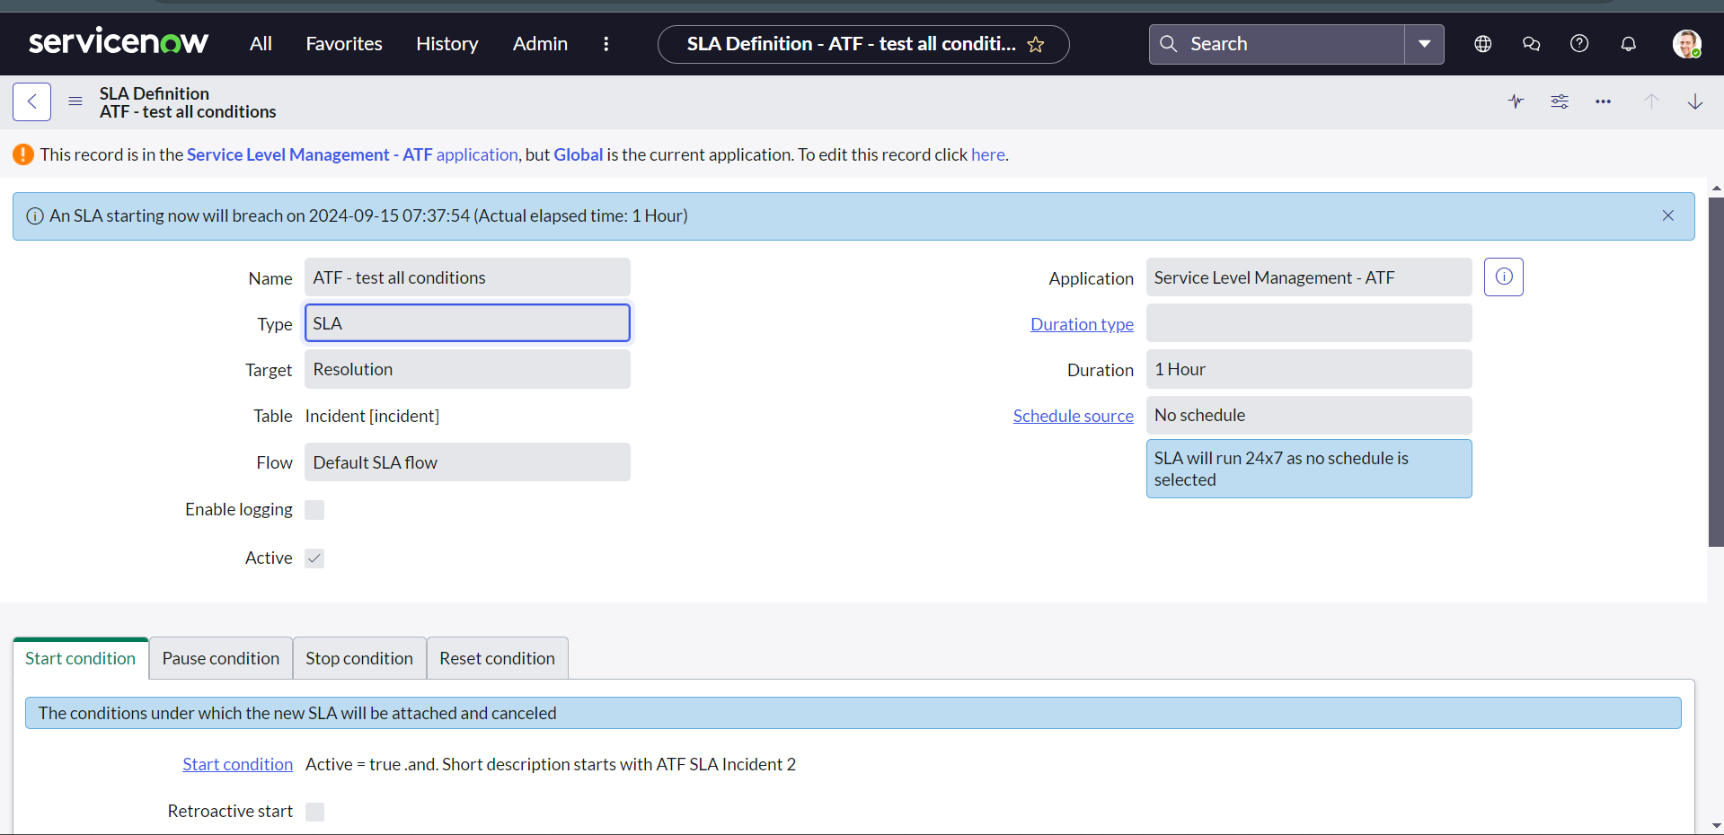Ways of Task Assignment:

* Manual
* Assignment rule
* Predictive Intelligence
* Custom Rules or Script

Here we can give a particular user or an assignment group to the individual record. 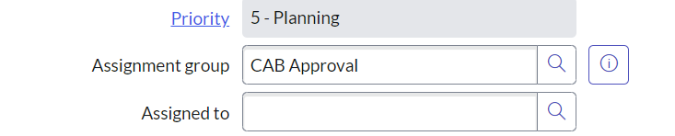assignment rules:

Under system policy> rules> assignment we can see the three categories applies to, assign to, script for the assingnment of different types of issues.

The trigger condition is set to automatically assign the rule when the condition is satisfied. 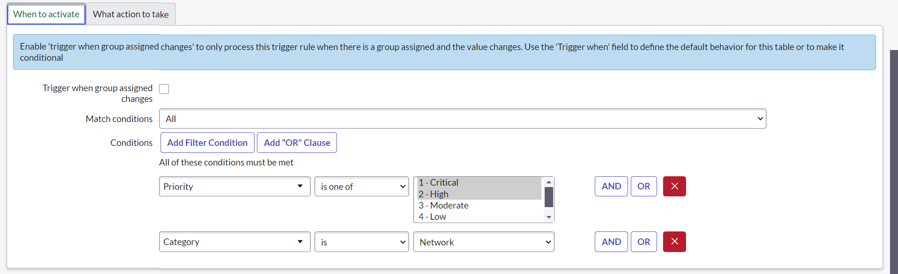

Service desk application:

Service desk helps in the viewing of different important field that a user can probably work on need like incidents, knowledge modules, my work which are assigned to the user.

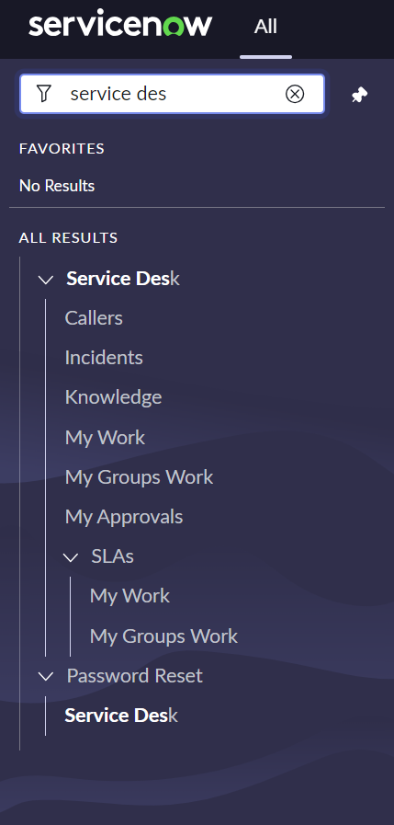

We can impersonate user and see the my work for the assigned work for a particular role and now I impersonated as an itil user. 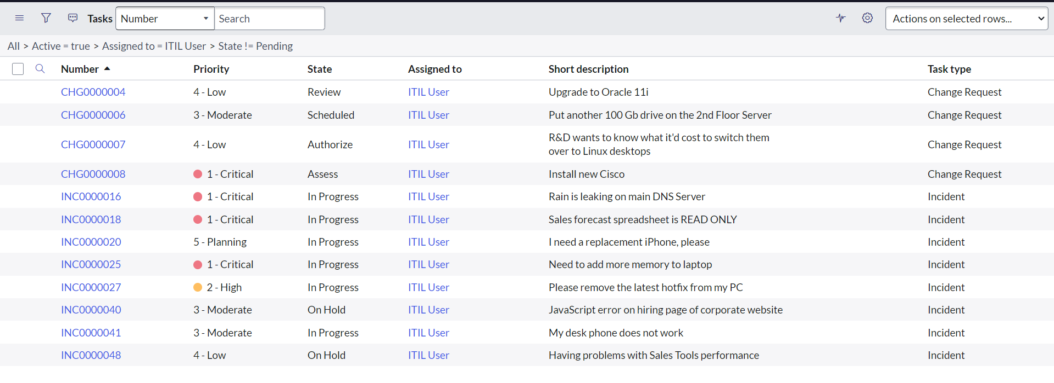now I can add the worknotes according to the workflow and can send the emails for the respective user. 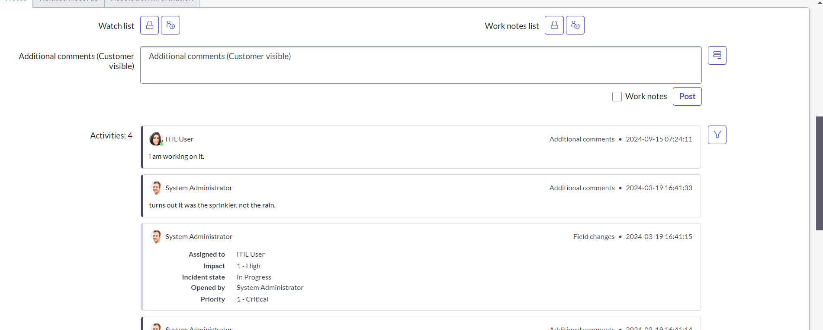 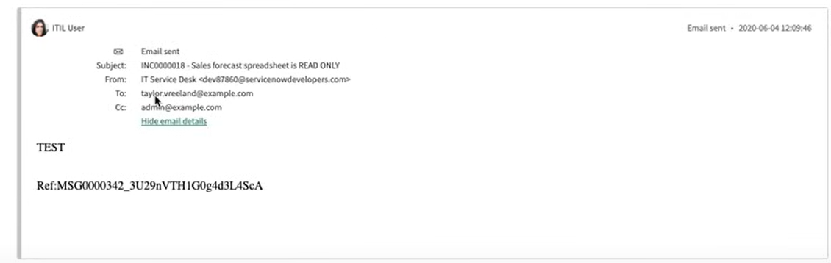

Notifications:

There are two types outbound and inbound, the notification created from the servicenow and received by the user regarding ay incident or task is called outbound email.

Inbound action is when a user makes an email and sends for the servicenow requesting or asking of creation of any kind of incidents or tasks is called as inbound action.

Three sub-categories in the system notification:

* Email – notification is send through the mail for the user
* Push – send through the push up notifications for the mobile
* Provider – used to send through agent workspace and virtual agent.

Creating notification:

* We need to navigate to notifications and then choose new.
* Now add the details of name, table and category of the notification.
* Fill the when to send module with mentioning the trigger for the notification.
* Also fill the who will receive when the trigger is satisfied and the groups and users.
* Mention the contents of the email that needs to be sent to the user when triggered. 